Angular tutorial v19
https://www.youtube.com/watch?v=jYV2enNmplM

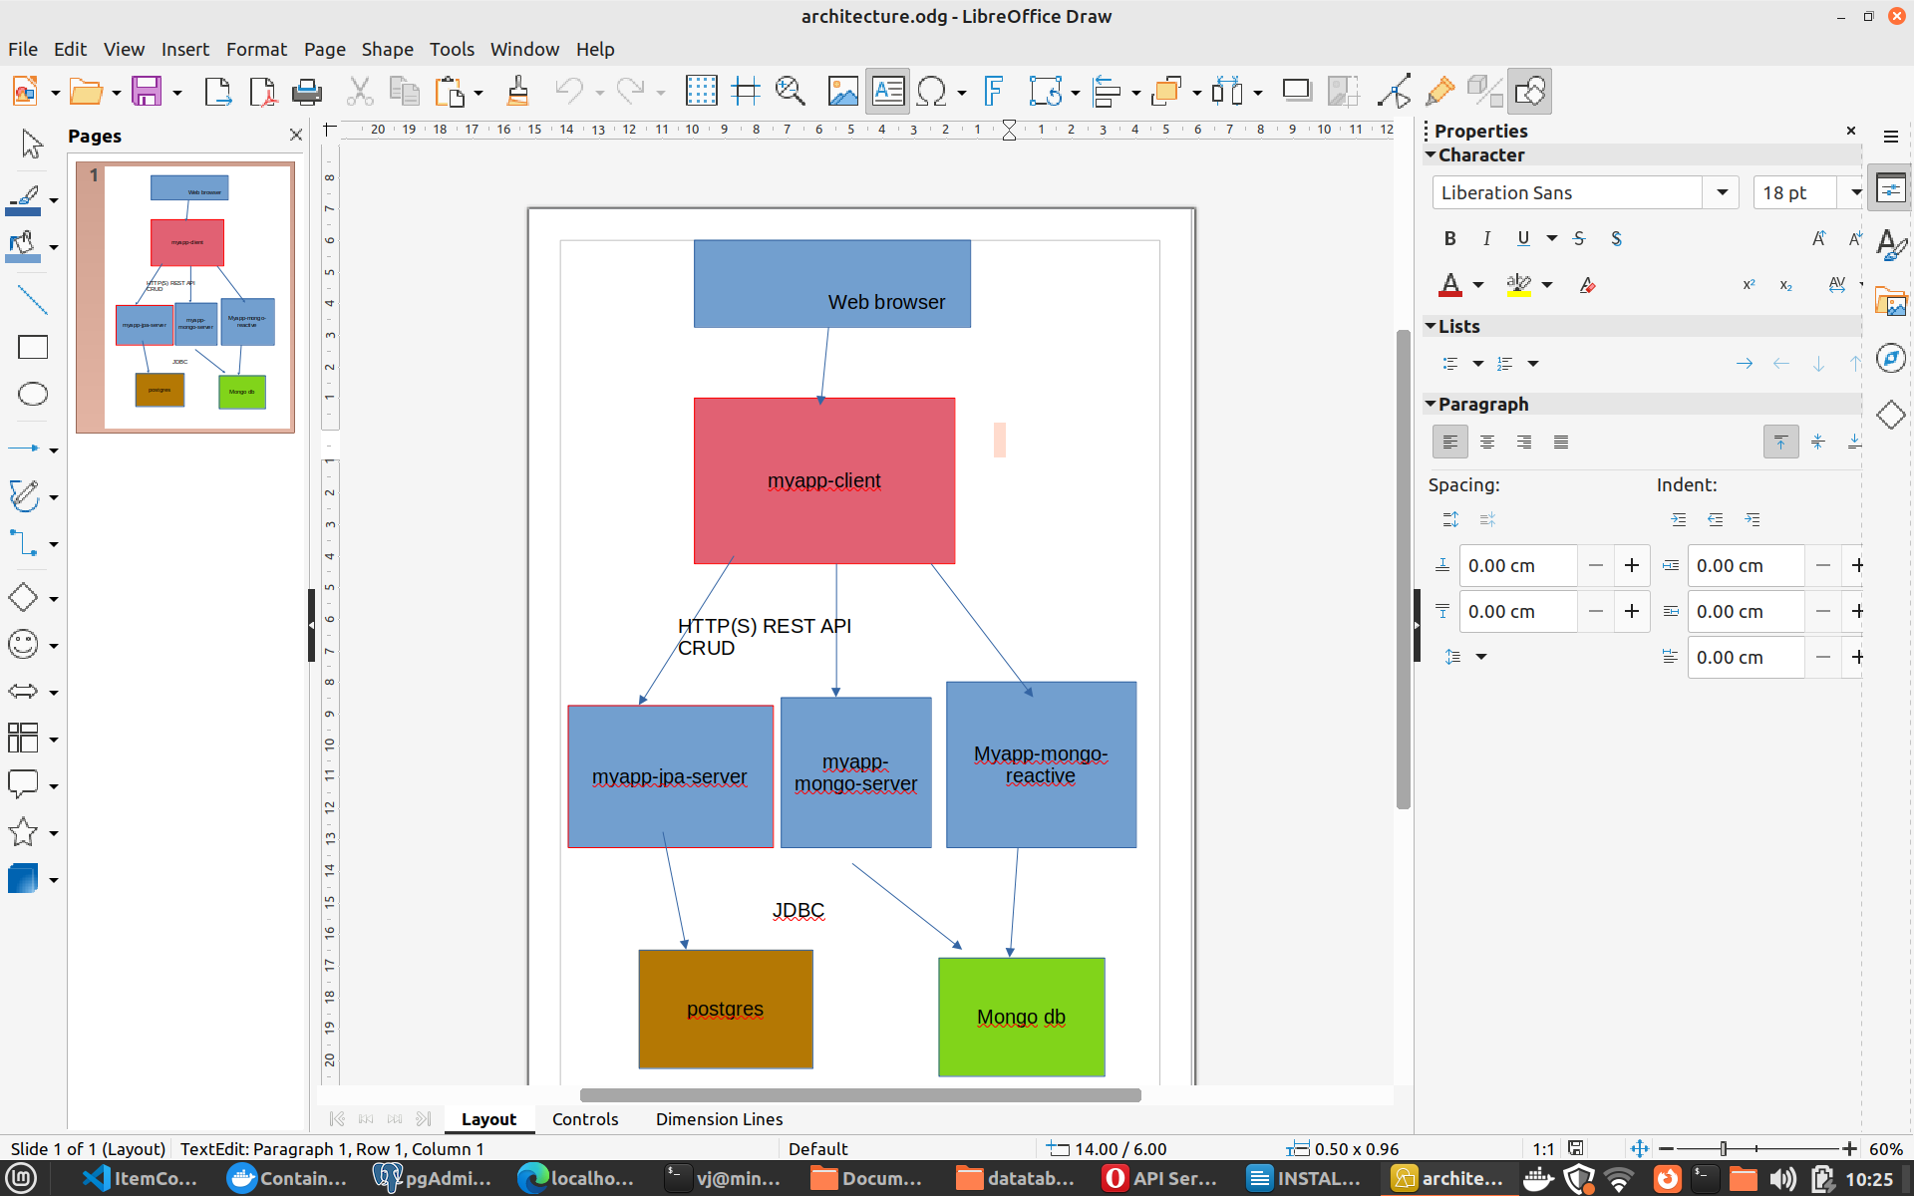

Myapp Application

1. Download tools
Docker Desktop
- pgAdmin
https://pgadmin-archive.postgresql.org/pgadmin4/apt/jammy/dists/pgadmin4/main/binary-amd64/index.html

maybe you need to install python3.10!!!
sudo add-apt-repository ppa:deadsnakes/ppa
sudo apt update
sudo apt install python3.10 python3.10-venv
sudo apt update
sudo apt install pgadmin4
or use debian package:
https://pgadmin-archive.postgresql.org/pgadmin4/apt/jammy/dists/pgadmin4/main/binary-amd64/index.html
MAKE SURE YOU INSTALL pgadmin4-desktop_9.11-1.jammy_amd64.deb
https://www.google.com/search?client=opera&q=Error%3A+Dependency+is+not+satisfiable%3A+python3.10&sourceid=opera&ie=UTF-8&oe=UTF-8
- git
- vs code
- dbeaver-ce
https://dbeaver.io/download/
- Angular 19 or 20
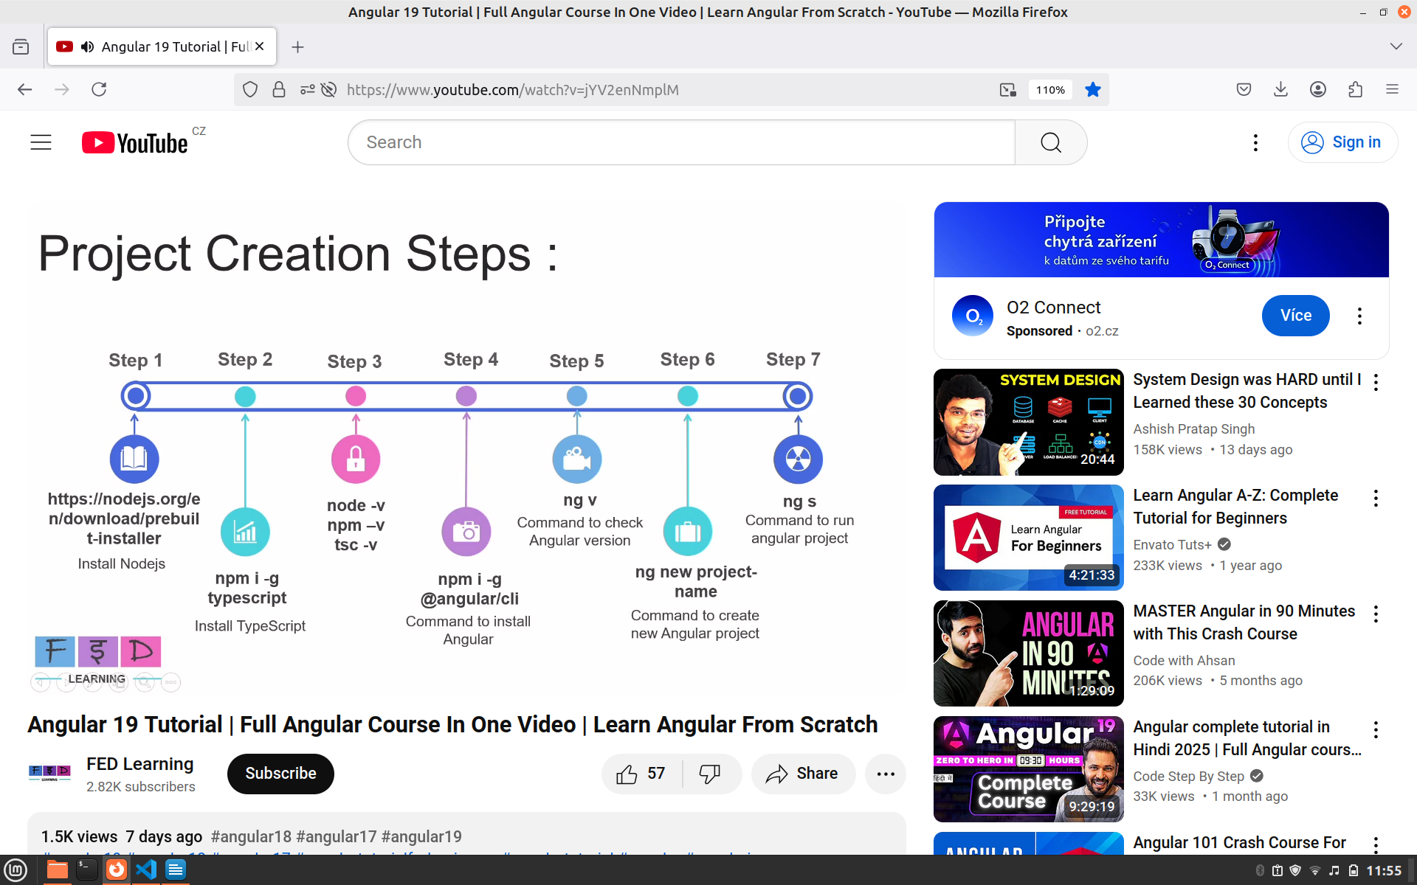
- DOWNLOAD JAVA 24

2. Download docker images

postgres:latest

litmuschaos/mongo
Or any other versioned image so it’s not downloaded every time you run docker tests with testcontainers

You can do it by the following commands
docker pull postgres
docker pull mongodb/mongodb-community-server

User logging when spring-security is on the classpath
Using generated security password:
Username: user
Password can be found in the run log: 4ba792da-2c3f-4995-ba2d-8984566be5eb

LOAD BALLANCER
docker compose up --scale backend=7 --build

When you build docker-compose up –build
before that you should delete containers which are part of the compose project, and images too.
delete existing containers in docker desktop
docket compose down
docker compose up --build
docker compose up

This way you run the application JPA/Mongo
docker-compose.yml is on locations:
datatables/myapp-jpa-server/docker-compose.yml

Docker compose
Simplifying Deployment: With a single docker-compose.yml file, you can start, stop, and manage your entire application stack with simple commands like docker compose up and docker-compose down. This simplifies deployment and makes it more repeatable.

Build and run steps
In RabbitMQ create 2 queues in - PROBABLY NOT NECESSARY STEP BECAUSE myapp-jpa-server contains definition of queues.
new-employee-queue
updated-employees-queue
Make them durable

datatables/build.sh
this command builds myapp-client and myapp-jpa-server
You should run the command when you want to use docker compose up.
docket-compose down
docker-compose up –build
docker-compose up
The commands will create the docker images and run the containers as you can see in Docker Desktop application.

Docker-compose up : NETWORK CHANGED

docker-compose up ERROR: Network "myapp-jpa-server_default" needs to be recreated - option "com.docker.network.enable_ipv6" has changed

Find a proceess running on port 9090
- sudo lsof -i :9090

Create database in pgAdmin
mydatabase

docker run --name some-postgres -e POSTGRES_PASSWORD=mysecretpassword -d -p 5432:5432 postgres

Spring profiles
java -Dspring.profiles.active=prod -jar target/myapp-jpa-server-1.0.0.jar

Create mvn in project:
mvn -N io.takari:maven:wrapper

Install angular 19 or 20
- Instal NodeJS
https://nodejs.org/en/download
or
- sudo apt install npm

# Download and install nvm:
curl -o- https://raw.githubusercontent.com/nvm-sh/nvm/v0.40.2/install.sh | bash

# in lieu of restarting the shell
\. "$HOME/.nvm/nvm.sh"

# Download and install Node.js:
nvm install 22

# Verify the Node.js version:
node -v # Should print "v23.11.0".
nvm current # Should print "v23.11.0".

# Verify npm version:
npm -v # Should print "10.9.2".

npm I -g typescript

Creating maven project
mvn archetype:generate -DgroupId=com.swaagger -DartifactId=demo -DarchetypeArtifactId=maven-archetype-quickstart -DinteractiveMode=false

- install typescript extension to visual studio code

First run docker dependencies

donwload docker images

Postgres container () I am not sure you need the following command
docker run --hostname=467ca158f369 --mac-address=1a:22:4b:7e:6b:f6 --env=POSTGRES_PASSWORD=password --env=PATH=/usr/local/sbin:/usr/local/bin:/usr/sbin:/usr/bin:/sbin:/bin:/usr/lib/postgresql/17/bin --env=GOSU_VERSION=1.17 --env=LANG=en_US.utf8 --env=PG_MAJOR=17 --env=PG_VERSION=17.5-1.pgdg120+1 --env=PGDATA=/var/lib/postgresql/data --volume=/var/lib/postgresql/data --network=bridge -p 5432:5432 --restart=no --runtime=runc -d postgres:latest

Number of watched files by OS
echo fs.inotify.max_user_watches=524288 | sudo tee -a /etc/sysctl.conf && sudo sysctl -p

################## RUN ##########################

Download music and myapp projects
git clone https://github.com/ahnsys1/MYAPP_AND_MUSIC.git

MyApp
mongo-myapp-client-release
myapp-backend-development
myapp-jpa-client-release

now let’s start backend first
myapp-backend-development/mvn clean install
myapp-backend-development/java -jar target/backend-0.0.1-SNAPSHOT.jar

myapp-client/npm i
mongo-myapp-client-release/ng s
OR: depending if you want to store data in MongoDB or in PostrgeSQL
myapp-client/npm i
myapp-client/ng s

sudo update-java-alternatives

npm i uuid --save
npm i jquery --save
npm i datatables.net --save
npm i datatables.net-dt --save
npm i angular-datatables --save
npm i @types/jquery --save-dev

npm i bootstrap5 --save

ng add @ng-bootstrap/ng-bootstrap

npm list -g
/home/vj/.nvm/versions/node/v23.11.0/lib
├── @angular/cli@19.2.6
├── corepack@0.32.0
├── npm@10.9.2
├── typescript@5.8.3
└── uuid@11.1.0

Manual for integrating datatables into Angular project
https://nipuanandawansha.medium.com/angular-datatables-with-angular-19-4ee54d989639

npm i @types/datatables.net --save-dev

npm i json-server

Angular_19/src/REST-endpoints$
json-server -w users-data.json

angular-datatables-master

https://github.com/l-lin/angular-datatables/tree/master

npm start

this starts development server
localhost:4200

npm i –save @types/jquery

ng add @angular/material

PROJECT EXPORT
git archive --format=zip --output zipfile.zip development

json-server -w employee-data.json

json-server -p 4000 -w users-data.json

http://localhost:4000/users

JSON PATH
JSONPATH.COM
jsonformatter.org

server
java -agentlib:jdwp=transport=dt_socket,server=y,suspend=y,address=8000 -jar target/backend-0.0.1-SNAPSHOT.jar

DOCKER
MONGODB
docker pull mongo
docker run -d --name my-mongodb -p
27017:27017 mongo

docker exec -it my-mongodb mongosh

docker pull postgres:16.9

/home/vj/Desktop/Angular/myapp-backed/backend
run without docker
mvn clean install
java -jar target/backend-0.0.1-SNAPSHOT.jar

run with docker
docker build -t myapp-backend:1.0.0 .
docker run -p 9090:9090 myapp-backend:1.0.0
docker container stop myapp-backend:1.0.0

run without docker
~/Desktop/Angular/myapp$
ng build
ng s or npm start
run with docker
docker build -t myapp-web:1.0.0 .
docker run -p 80:80 myapp-web:1.0.0
docker container stop myapp-web:1.0.0

MUSIC
docker build -t music:1.0.0 .
docker run -p 8080:8080 music:1.0.0
docker container stop music:1.0.0

Okay, here's how you can send a message to a specific queue using RabbitTemplate in Spring AMQP:
java
import org.springframework.amqp.rabbit.core.RabbitTemplate;
import org.springframework.beans.factory.annotation.Autowired;
import org.springframework.stereotype.Component;

@Component
public class MessageSender {

@Autowired
private RabbitTemplate rabbitTemplate;

public void sendMessage(String queueName, String message) {
rabbitTemplate.convertAndSend(queueName, message);
}
}
Explanation:
- @Autowired private RabbitTemplate rabbitTemplate;: This line injects an instance of RabbitTemplate into your class. RabbitTemplate is the core class for sending messages to RabbitMQ.
- rabbitTemplate.convertAndSend(queueName, message);: This is the key line.
  - queueName: This is a String that specifies the name of the queue you want to send the message to.
  - message: This is the message you want to send. The convertAndSend method will automatically convert the message object to a byte array using a message converter. The default converter is a SimpleMessageConverter, which works well for simple String messages.
Example Usage:
java
@Autowired
MessageSender messageSender;

public void someMethod() {
String queueName = "myQueue";
String message = "Hello, RabbitMQ!";
messageSender.sendMessage(queueName, message);
}
Important Considerations:
- Queue Declaration: Make sure the queue you're sending to (myQueue in the example) has been declared in your RabbitMQ configuration. If the queue doesn't exist, the message might be lost (depending on your RabbitMQ configuration and exchange settings). The RabbitMQConfig.java file in the context shows how to declare a queue.
- Message Conversion: If you need to send more complex objects than simple strings, you might need to configure a custom message converter. Spring AMQP provides several built-in converters (like Jackson2JsonMessageConverter for JSON).
- Exchange: While this example sends directly to a queue, you can also send messages to an exchange, which then routes the message to one or more queues based on routing keys and exchange type. The RabbitMQConfig.java file in the context shows how to declare an exchange and bind it to a queue. To send to an exchange, you'd use a different overload of convertAndSend:
java
rabbitTemplate.convertAndSend(exchangeName, routingKey, message);
Where exchangeName is the name of the exchange, and routingKey is used for routing.
- Error Handling: Consider adding error handling (e.g., try-catch blocks) around the convertAndSend method to handle potential exceptions during message sending. The EmployeeMongoService.java file in the context shows an example of error handling.

LIST OF Images and Containers
docker images
docker container ps

removes all stopped contianers
docker container prune

remove all stopped containers
docker container prune

Show containers
docker container ps -a

docker run -p 9090:9090 myapp-backend
docker run -p 80:80 myapp-web

use mydb
db.createCollection("users")
db.users.insertOne({name: "John Doe", email: "john@example.com"})

TEST USE OF PERSISTENCE
docker stop my-mongodb
docker rm my-mongodb

TEST DB FIND
docker exec -it my-mongodb mongo
use mydb
db.users.find()

Where is the Docker volume?
/var/lib/docker/volume
Volumes are also stored as part of the host file system, which is managed by Docker. On Linux, volumes are stored in “/var/lib/docker/volume”.

https://shamsfiroz.medium.com/running-mongodb-in-docker-a-practical-guide-2b4cf39d5d60

https://www.baeldung.com/ops/docker-mounting-multiple-volumes

https://www.mongodb.com/resources/products/compatibilities/spring-boot

https://www.baeldung.com/spring-data-
mongodb-tutorial

RUN PGADMIN
https://www.pgadmin.org/docs/pgadmin4/latest/container_deployment.html

docker pull dpage/pgadmin4

docker run -p 180:180 \ -e 'PGADMIN_DEFAULT_EMAIL=user@domain.com' \
-e 'PGADMIN_DEFAULT_PASSWORD=SuperSecret' \
-e 'PGADMIN_CONFIG_ENHANCED_COOKIE_PROTECTION=True' \
-e 'PGADMIN_CONFIG_LOGIN_BANNER="Authorised users only!"' \
-e 'PGADMIN_CONFIG_CONSOLE_LOG_LEVEL=10' \
-d dpage/pgadmin4

2025-05-27 21:22:40.942 | Error: Database is uninitialized and superuser password is not specified.
2025-05-27 21:22:40.942 | You must specify POSTGRES_PASSWORD to a non-empty value for the
2025-05-27 21:22:40.942 | superuser. For example, "-e POSTGRES_PASSWORD=password" on "docker run".
2025-05-27 21:22:40.942 |
2025-05-27 21:22:40.942 | You may also use "POSTGRES_HOST_AUTH_METHOD=trust" to allow all
2025-05-27 21:22:40.942 | connections without a password. This is *not* recommended.
2025-05-27 21:22:40.942 |
2025-05-27 21:22:40.942 | See PostgreSQL documentation about "trust":
2025-05-27 21:22:40.942 | https://www.postgresql.org/docs/current/auth-trust.html

How to integrate backend with frontend (myapp, myapp-backed);
1. ng build for myapp (web)

2 Copy myapp/dist/myapp/browser content into myapp-backedsrc/main/resources/static

3. mvn clean install in project myapp-backend

4. java -jar target/backend-0.0.1-SNAPSHOT.jard a docker image

Angular material
ng add @angular/material

KAFKA
working directory:
/opt/kafka/bin
VYTVORENI TOPICU
./kafka-topics.sh --bootstrap-server localhost:9092 --topic myapp-topic --create --partitions 3 --replication-factor 1

VYPSANI VSECH TOPICU
/opt/kafka/bin $ ./kafka-topics.sh --bootstrap-server localhost:9092 --list

Delete topic
-92 --delete --topic first_topic --bootstrap-server localhost:9092 --delete –top

ic f092 --delete --topic first_topic# Stage 1: Build the Angular application
FROM node:20-alpine AS builder
WORKDIR /app

# Copy package files and install dependencies
COPY package*.json ./
RUN npm install

# Copy the rest of the application source code
COPY . .

# Build the application for production
RUN npm run build

# Stage 2: Serve the application with a lean Nginx server
FROM nginx:alpine

CMD ["ng", "build"]

# Copy the built application from the builder stage
COPY dist/myapp/browser /usr/share/nginx/html

# Expose port 80
COPY --from=builder /app/dist/angular-19/browser /usr/share/nginx/html
EXPOSE 80

# Command to start nginx
CMD ["nginx", "-g", "daemon off;"]

# Stage 1: Build the Angular application
FROM node:20-alpine AS builder
WORKDIR /app

# Copy package files and install dependencies
COPY package*.json ./
RUN npm install

# Copy the rest of the application source code
COPY . .

# Build the application for production
RUN npm run build

# Stage 2: Serve the application with a lean Nginx server
FROM nginx:alpine

CMD ["ng", "build"]

# Copy the built application from the builder stage
COPY dist/myapp/browser /usr/share/nginx/html

# Expose port 80
COPY --from=builder /app/dist/angular-19/browser /usr/share/nginx/html
EXPOSE 80

# Command to start nginx
CMD ["nginx", "-g", "daemon off;"]

Of course, I can help with that. The traceback you're seeing with docker-compose down indicates that docker-compose is unable to communicate with the Docker daemon on your machine. The 500 Server Error suggests that the Docker daemon itself is having a problem.
This is a common issue, and here are the most likely causes and how to fix them, in order from most to least common:

1. The Docker Daemon Isn't Running
The most frequent cause is that the Docker service isn't running. You can check its status and start it if needed.
Open your terminal and run:
bash
sudo systemctl status docker
If it's not active, you can start it with:
bash
sudo systemctl start docker
After starting it, try your docker-compose down command again.

2. Permission Issues
The user you're logged in as might not have the required permissions to access the Docker socket.
- Quick Test: Try running the command with sudo.
bash
sudo docker-compose down
- Permanent Fix: To avoid using sudo every time, you can add your user to the docker group.
bash
sudo usermod -aG docker ${USER}
You will need to log out and log back in for this change to take effect.

3. Docker Daemon is in a Bad State
Sometimes, the Docker daemon can get into an unresponsive state. A simple restart can often fix this.
bash
sudo systemctl restart docker

4. Outdated Docker or docker-compose
You are using docker-compose version 1.29.2, which is the older V1 standalone version. The current standard is docker compose V2, which is a plugin for the Docker CLI. While V1 should still work, issues can arise.
You could try using the V2 command:
bash
docker compose down
If none of these steps work, the issue might be a more complex problem with your Docker installation itself, and you might consider reinstalling Docker.
I hope this helps you get your containers down! Let me know if you have any other questions.

Of course, I can help with that. The traceback you're seeing with docker-compose down indicates that docker-compose is unable to communicate with the Docker daemon on your machine. The 500 Server Error suggests that the Docker daemon itself is having a problem.
This is a common issue, and here are the most likely causes and how to fix them, in order from most to least common:

1. The Docker Daemon Isn't Running
The most frequent cause is that the Docker service isn't running. You can check its status and start it if needed.
Open your terminal and run:
bash
sudo systemctl status docker
If it's not active, you can start it with:
bash
sudo systemctl start docker
After starting it, try your docker-compose down command again.

2. Permission Issues
The user you're logged in as might not have the required permissions to access the Docker socket.
- Quick Test: Try running the command with sudo.
bash
sudo docker-compose down
- Permanent Fix: To avoid using sudo every time, you can add your user to the docker group.
bash
sudo usermod -aG docker ${USER}
You will need to log out and log back in for this change to take effect.

3. Docker Daemon is in a Bad State
Sometimes, the Docker daemon can get into an unresponsive state. A simple restart can often fix this.
bash
sudo systemctl restart docker

4. Outdated Docker or docker-compose
You are using docker-compose version 1.29.2, which is the older V1 standalone version. The current standard is docker compose V2, which is a plugin for the Docker CLI. While V1 should still work, issues can arise.
You could try using the V2 command:
bash
docker compose down
If none of these steps work, the issue might be a more complex problem with your Docker installation itself, and you might consider reinstalling Docker.
I hope this helps you get your containers down! Let me know if you have any other questions.

Of course, I can help with that. The traceback you're seeing with docker-compose down indicates that docker-compose is unable to communicate with the Docker daemon on your machine. The 500 Server Error suggests that the Docker daemon itself is having a problem.
This is a common issue, and here are the most likely causes and how to fix them, in order from most to least common:

1. The Docker Daemon Isn't Running
The most frequent cause is that the Docker service isn't running. You can check its status and start it if needed.
Open your terminal and run:
bash
sudo systemctl status docker
If it's not active, you can start it with:
bash
sudo systemctl start docker
After starting it, try your docker-compose down command again.

2. Permission Issues
The user you're logged in as might not have the required permissions to access the Docker socket.
- Quick Test: Try running the command with sudo.
bash
sudo docker-compose down
- Permanent Fix: To avoid using sudo every time, you can add your user to the docker group.
bash
sudo usermod -aG docker ${USER}
You will need to log out and log back in for this change to take effect.

3. Docker Daemon is in a Bad State
Sometimes, the Docker daemon can get into an unresponsive state. A simple restart can often fix this.
bash
sudo systemctl restart docker

4. Outdated Docker or docker-compose
You are using docker-compose version 1.29.2, which is the older V1 standalone version. The current standard is docker compose V2, which is a plugin for the Docker CLI. While V1 should still work, issues can arise.
You could try using the V2 command:
bash
docker compose down
If none of these steps work, the issue might be a more complex problem with your Docker installation itself, and you might consider reinstalling Docker.
WEB BROWSER
I hope this helps you get your containers down! Let me know if you have any other questions.

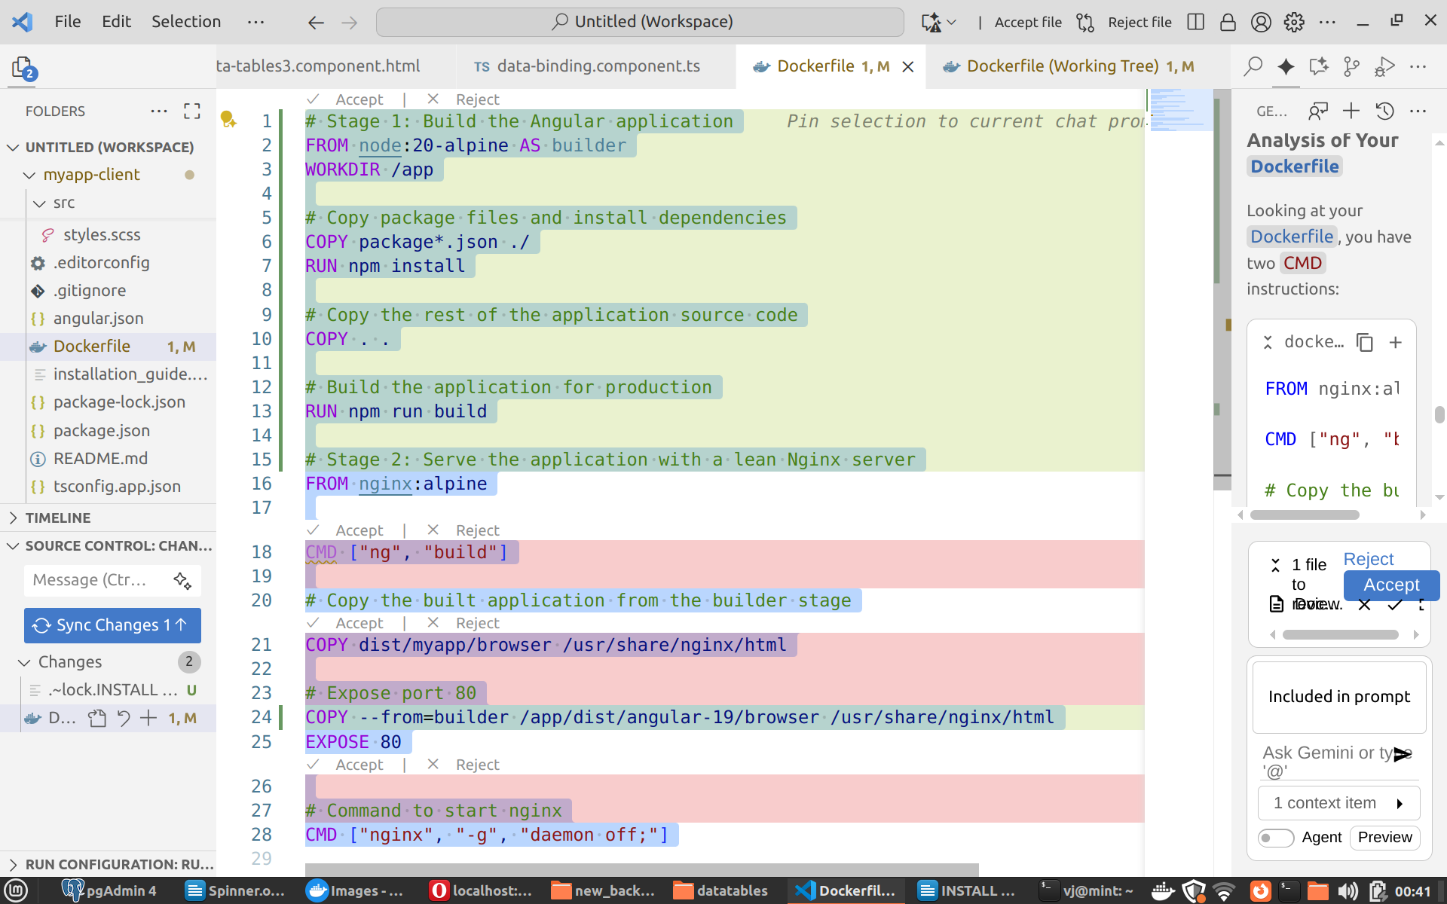
SPING BOOT PERMISSIONS
CREATE FOLDER /etc/rabbitmq
set chown docker
set chgrp docker
set chmod 777
chown vj rabbitmq
Of course! Creating an HTTP client for a project with Swagger (now known as OpenAPI) endpoints is a common task. The best and most professional approach is to auto-generate a typed client from your API's OpenAPI specification file. This saves you time, reduces bugs, and makes your client automatically update when the API changes.
Let's walk through how to do this for your swagger_demo1 project.

What You'll Need: The OpenAPI Specification
First, you need the OpenAPI specification file from your project. This is a JSON or YAML file that describes all of your API's endpoints, models, and operations. Usually, a Swagger-enabled application exposes this file at a URL like:
- /swagger/v1/swagger.json
- /openapi.json
- /api-docs
Find this URL in your swagger_demo1 application, and save the contents as a file named openapi.json in your client project's root directory.

Recommended Approach: Auto-Generate a Client
We will use openapi-generator-cli, a powerful tool that can generate clients (and servers) in many languages. Since your project context appears to be Node.js/TypeScript based, I'll provide an example for that environment.

Step 1: Install the Generator
In your client-side project, install the generator CLI as a development dependency.
bash
npm install @openapitools/openapi-generator-cli --save-dev

Step 2: Generate the Client Code
Now, you can run the generator. This command will read your openapi.json file and generate a complete TypeScript client using axios for HTTP requests.
Add a script to your package.json for convenience:
json
{
"scripts": {
"generate-api-client": "openapi-generator-cli generate -i openapi.json -g typescript-axios -o ./src/api-client --additional-properties=usePromises=true"
}
}
Now, run the script:
bash
npm run generate-api-client
Let's break down that command:
- -i openapi.json: Specifies the input OpenAPI specification file.
- -g typescript-axios: Specifies the generator to use. There are many others for different languages and libraries (e.g., typescript-fetch, java, python, go).
- -o ./src/api-client: Specifies the output directory for the generated code.
- --additional-properties=usePromises=true: A generator-specific option to ensure the client returns modern Promises.
This will create a new directory, ./src/api-client, containing a fully-typed client for your API.

Step 3: Use the Generated Client
Now you can import and use your new client. The generated code is easy to work with and provides full type safety and autocompletion for your API's endpoints and models.
Here is an example of how you might use it:
typescript
// src/services/my-api-service.ts

import { Configuration, DefaultApi } from '../api-client';

// You can configure the base path and other options
const config = new Configuration({
basePath: 'http://localhost:8080', // Your swagger_demo1 API base URL
});

// Instantiate the API client
const apiClient = new DefaultApi(config);

// Now you can call your API endpoints as methods
export const fetchUsers = async () => {
try {
// The method name (e.g., usersGet) is generated from your OpenAPI spec.
// You get full type safety on parameters and return types!
const response = await apiClient.usersGet();

console.log('API Response:', response.data);
return response.data; // This will be a typed array, e.g., User[]
} catch (error) {
console.error('Failed to fetch users:', error);
throw error;
}
};

export const createUser = async (newUser: any) => { // Replace 'any' with the generated User model
try {
// Example for a POST request
const response = await apiClient.usersPost(newUser);
console.log('User created:', response.data);
return response.data;
} catch (error) {
console.error('Failed to create user:', error);
throw error;
}
}

Alternative: Manual Client with axios
You could write the client manually, but I strongly advise against it for any non-trivial API. It's brittle and requires a lot of boilerplate.
Here's how you might make a single call manually for comparison:
typescript
import axios from 'axios';

const apiClient = axios.create({
baseURL: 'http://localhost:8080', // Your swagger_demo1 API base URL
});

export const fetchUsersManually = async () => {
try {
// No type safety for the URL, parameters, or response
const response = await apiClient.get('/users');
return response.data;
} catch (error) {
console.error('Failed to fetch users:', error);
throw error;
}
};
Drawbacks of the manual approach:
- No Type Safety: You lose all benefits of TypeScript for your API contract.
- Error-Prone: It's easy to make typos in URLs or mismatches in request/response shapes.
- High Maintenance: If an endpoint changes in swagger_demo1, you have to manually find and update it in your client code. With a generated client, you just re-run the generator script.
Using a code generator is the standard in modern development for consuming OpenAPI-documented services. It establishes a reliable, type-safe contract between your frontend and backend.

how to access HTTP endpoint which is login page protected? Which tool to use for it?

Gemini
Thinking
Of course! I can certainly explain how to access endpoints protected by a login page and the tools you can use.
Based on your project's SecurityConfig.java file, your application is configured to use Spring Security's form-based login.
java
// /home/vj/Desktop/A/backu20/swagger_demo1/src/main/java/com/swagger/demo/security/SecurityConfig.java
...
// Enable form-based login with default configuration
.formLogin(Customizer.withDefaults());
...
public UserDetailsService userDetailsService() {
UserDetails user = User.builder()
.username("user")
.password(passwordEncoder().encode("password"))
...
This means that to access any protected endpoint (like /api/items), you first need to authenticate by submitting a username and password to the /login endpoint. This process establishes a session, and a session cookie (typically JSESSIONID) is returned. You must then include this cookie in all subsequent requests to prove you are authenticated.
Here are several common tools and methods to do this:

1. API Clients (like Postman or Insomnia)
These graphical tools are excellent for manual testing and exploration. They automatically manage cookies for you, making the process straightforward.
Steps for Postman:
- Authenticate:
  - Create a POST request to http://localhost:9090/login.
  - In the Body tab, select x-www-form-urlencoded.
  - Add two key-value pairs:
    - username: user
    - password: password
  - Click Send. Postman will automatically receive and store the session cookie from the server's response.
- Access Protected Endpoint:
  - Now, create a GET request to http://localhost:9090/api/items.
  - Click Send. Postman will automatically attach the session cookie to this request, and you will receive a 200 OK response with the list of items.

2. Command-Line Tool (curl)
curl is a powerful command-line tool for making HTTP requests. It's ideal for scripting and automation. You need to manually manage the cookies.
Steps for curl:
- Authenticate and Save the Cookie: Run the following command to send a POST request to the /login endpoint. The -c cookies.txt flag tells curl to save the session cookie into a file named cookies.txt.
bash
curl -X POST -c cookies.txt -d "username=user" -d "password=password" http://localhost:9090/login
- Access Protected Endpoint with the Cookie: Now, make a request to the protected endpoint using the -b cookies.txt flag, which tells curl to include the cookies from that file in the request.
bash
curl -b cookies.txt http://localhost:9090/api/items
You will see the JSON response containing the items, as you are now authenticated.

3. Automated Integration Tests (Spring's MockMvc)
For automated testing, performing a full login for every test is inefficient. Spring Security's testing support provides a much better way.
Your existing test file, SwaggerDemoApplicationTests.java, already demonstrates the best practice using the @WithMockUser annotation. This annotation tells the testing framework to run the test with a mock authenticated user in the security context, completely bypassing the need to perform a login.
java
// /home/vj/Desktop/A/backu20/swagger_demo1/src/test/java/com/swagger/demo/SwaggerDemoApplicationTests.java
...
@Test
@WithMockUser // This annotation provides an authenticated user for the test
void getAllItems_shouldReturnInitialItems() throws Exception {
mockMvc.perform(get("/api/items"))
.andExpect(status().isOk())
...
}
...
This is the preferred method for writing integration tests for secured endpoints in a Spring application.

Code Improvement Suggestion
In your main application class, the @EnableWebSecurity annotation is redundant. spring-boot-starter-security automatically enables web security when it's on the classpath, and your SecurityConfig class already correctly contains this annotation. You can safely remove it from the main class for better clarity.
SwaggerDemoApplication.java
-2+0

import org.springframework.boot.SpringApplication;
import org.springframework.boot.autoconfigure.SpringBootApplication;
import org.springframework.security.config.annotation.web.configuration.EnableWebSecurity;

@EnableWebSecurity
@SpringBootApplication
public class SwaggerDemoApplication {

I hope this helps you understand how to work with your secured endpoints!
1 file to review.
Reject
SwaggerDemoApplication.java-2+0

1 context item

Context items
Current fileSwaggerDemoApplication.java

CSRF TOKEN
where to put _csrf parameter in http REST request in Postman?

Gemini
Thinking
Of course! You've run into a very common and important security feature in Spring Security. The _csrf parameter is required because your application has Cross-Site Request Forgery (CSRF) protection enabled by default, which is excellent for security.
For a traditional form-based login, this _csrf token must be sent in the body of the POST request to /login.

Where to Put the _csrf Parameter in Postman
You need to add the _csrf token as a key-value pair in the body of your request, using the x-www-form-urlencoded format. It goes right alongside your username and password fields.
- Set the request method to POST.
- Set the URL to http://localhost:9090/login.
- Go to the Body tab and select the x-www-form-urlencoded radio button.
- Add the following key-value pairs in the table:
  - username: user
  - password: password
  - _csrf: [THE-ACTUAL-CSRF-TOKEN-VALUE]
The main challenge is getting the correct value for the CSRF token, as your current configuration is designed for browser-based forms, not API clients. Here are two ways to handle this.

Option 1: The Easy Way for Development (Disable CSRF)
For quick testing and development, the simplest solution is to temporarily disable CSRF protection. This removes the need for the _csrf token entirely.
Warning: Do not do this in a production application that will be accessed by browsers, as it opens you up to CSRF attacks.

Change SecurityConfig.java:
You can disable CSRF by adding .csrf(csrf -> csrf.disable()) to your security filter chain.
SecurityConfig.java
-0+2
@Bean
public SecurityFilterChain securityFilterChain(HttpSecurity http) throws Exception {
http
// WARNING: Disables CSRF protection. Do not use in production for browser-based clients.
.csrf(csrf -> csrf.disable())
.authorizeHttpRequests(authorize -> authorize
// Allow unauthenticated access to Swagger UI resources
.requestMatchers(SWAGGER_WHITELIST).permitAll()

After this change, restart your application. Your login request in Postman will now succeed with only the username and password fields.

Option 2: The "Proper" Way for API Clients (Expose Token in a Cookie)
A more secure and production-friendly approach is to configure Spring Security to send the CSRF token in a cookie. This is the standard practice for applications that will be consumed by Single-Page Applications (SPAs) or other API clients.

Change SecurityConfig.java:
Modify your security configuration to use CookieCsrfTokenRepository. This will cause Spring Security to set a cookie named XSRF-TOKEN on the first GET request.
SecurityConfig.java
-1+5
import org.springframework.security.config.annotation.web.builders.HttpSecurity;
import org.springframework.security.config.annotation.web.configuration.EnableWebSecurity;
import org.springframework.security.core.userdetails.User;
import org.springframework.security.core.userdetails.UserDetails;
import org.springframework.security.core.userdetails.UserDetailsService;
import org.springframework.security.crypto.bcrypt.BCryptPasswordEncoder;
import org.springframework.security.crypto.password.PasswordEncoder;
import org.springframework.security.provisioning.InMemoryUserDetailsManager;
import org.springframework.security.web.SecurityFilterChain;
import org.springframework.security.web.csrf.CookieCsrfTokenRepository;

@Configuration
@EnableWebSecurity
@Bean
public SecurityFilterChain securityFilterChain(HttpSecurity http) throws Exception {
http
.csrf(csrf -> csrf
// Send the CSRF token in a cookie (XSRF-TOKEN) that JavaScript can read.
.csrfTokenRepository(CookieCsrfTokenRepository.withHttpOnlyFalse())
)
.authorizeHttpRequests(authorize -> authorize
// Allow unauthenticated access to Swagger UI resources
.requestMatchers(SWAGGER_WHITELIST).permitAll()

New Workflow in Postman:
After restarting your app with this change, follow these steps:
- Get the Token: Make a GET request to any endpoint, for example, http://localhost:9090/api/items. The request will fail with a 401 Unauthorized or redirect, but that's expected.
- Inspect Cookies: In the Postman response viewer, click the Cookies tab. You will see a cookie named XSRF-TOKEN. Copy its Value.
- Log In: Now, build your POST request to http://localhost:9090/login as described at the top, and paste the copied token value into the _csrf field in the request body.
- Send Request: Click Send. Postman automatically includes the necessary session cookies, and your login will succeed. You can then access your protected endpoints.
I recommend Option 2 as it maintains security while making your API friendly to other clients.

The expression $[?(@.name == 'Employee')] is a JSONPath query. JSONPath is a way to select and extract specific parts of a JSON document. It's very similar in concept to how XPath is used for XML.
This specific expression is used in your test file EmployeeMongoControllerTest.java to find a particular object within a JSON array returned by one of your API endpoints.

Explanation of the Expression
Let's break it down piece by piece:
- $: This represents the root of the JSON document. In the context of your test, it refers to the entire JSON array returned by the API.
- [...]: This is the subscript operator. When it contains a ?(), it acts as a filter.
- ?(): This is the filter operator. It iterates through a collection of elements and selects only those that match a specific condition.
- @: Inside the filter, the @ symbol represents the current element being processed in the array.
- .name: This accesses the name property of the current element (@).
- == 'Employee': This is the comparison. It checks if the value of the name property is exactly equal to the string 'Employee'.
Putting it all together, the expression $[?(@.name == 'Employee')] means:
"From the root of the JSON document ($), find all elements in the array ([...]) where (?()) the current element's (@) name property is equal to 'Employee'."

In the Context of Your Code
In /home/vj/Desktop/A/backu20/datatables/myapp-mongo-server/src/test/java/com/angular/backend/employees/EmployeeMongoControllerTest.java, you have this line:
java
// ...
.andExpect(jsonPath("$[?(@.name == 'Employee')].manager.name", contains("Manager")));
Here, the JSONPath is slightly longer: $[?(@.name == 'Employee')].manager.name.
- $[?(@.name == 'Employee')]: First, it finds the employee object in the response array whose name is "Employee". This part of the expression returns a new array containing just that one employee object.
- .manager: From that resulting array, it then navigates into the manager object for each element.
- .name: Finally, it selects the name property from the manager object.
The test then asserts that the value of the manager's name is "Manager".
So, that line of code is testing that for the employee named "Employee", their manager's name is correctly set to "Manager" in the API response.

Install docker compose 2.11
mkdir -p ~/.docker/cli-plugins

curl -sSL https://github.com/docker/compose/releases/download/v2.11.0/docker-compose-linux-x86_64 -o ~/.docker/cli-plugins/docker-compose

chmod +x ~/.docker/cli-plugins/docker-compose

docker compose version
# Docker Compose version v2.11.0

# This will let you run docker compose in the new form `docker compose .f compose.yaml up`

# References: https://www.rockyourcode.com/how-to-install-docker-compose-v2-on-linux-2021/
Of course. Scaling your WebSocket-enabled backend is a classic challenge, and you've correctly identified the core issue. When you run multiple instances of your server, each instance manages its own set of WebSocket connections. A message sent to one server instance won't be seen by clients connected to other instances.

The Problem: Isolated Message Brokers
By default, Spring's WebSocket support uses a simple, in-memory message broker. This broker is local to each of your backend instances.
plaintext
Client A --ws--> Backend 1 (In-Memory Broker 1)
Client B --ws--> Backend 2 (In-Memory Broker 2)
Client C --ws--> Backend 3 (In-Memory Broker 3)
If Client B sends a message to /app/send-log on Backend 2, Backend 2 will broadcast it to /topic/logs. However, only clients connected to Backend 2 will receive it. Client A and Client C will get nothing because their backends know nothing about the message.

The Solution: External STOMP Broker Relay
To solve this, you need to use an external message broker that all your backend instances can connect to. This creates a central hub for messages. When one backend instance receives a message to be broadcast, it sends it to the external broker, which then relays it to all connected backend instances. Each backend instance then pushes the message to its own connected clients.
Since your project is already configured with RabbitMQ for handling employee updates, we can easily leverage it to also manage your WebSocket messages. We'll configure Spring to use RabbitMQ as a STOMP "broker relay".
Here is the architecture we'll build:
plaintext
+--------------------------------+
| RabbitMQ Broker |
+--------------------------------+
/ | \
STOMP over TCP STOMP over TCP STOMP over TCP
/ | \
+-----------+ +-----------+ +-----------+
| Backend 1 |<----->| Backend 2 |<------>| Backend 3 |
+-----------+ +-----------+ +-----------+
^ ^ ^
| ws | ws | ws
+----------+ +----------+ +----------+
| Client A | | Client B | | Client C |
+----------+ +----------+ +----------+

Implementation Steps
I'll create a new configuration file to enable the STOMP broker relay with RabbitMQ.

1. Create WebSocketConfig.java
This new configuration class will set up your WebSocket endpoints and configure the message broker to use RabbitMQ.
New file: WebSocketConfig.java
+40
package com.angular.backend.config;

import org.springframework.context.annotation.Configuration;
import org.springframework.messaging.simp.config.MessageBrokerRegistry;
import org.springframework.web.socket.config.annotation.EnableWebSocketMessageBroker;
import org.springframework.web.socket.config.annotation.StompEndpointRegistry;
import org.springframework.web.socket.config.annotation.WebSocketMessageBrokerConfigurer;

@Configuration
@EnableWebSocketMessageBroker
public class WebSocketConfig implements WebSocketMessageBrokerConfigurer {

@Override
public void configureMessageBroker(MessageBrokerRegistry config) {
// These are prefixes for messages that are bound for @MessageMapping-annotated methods.
// A client would send a message to a destination like "/app/send-log".
config.setApplicationDestinationPrefixes("/app");

// Use the STOMP broker relay.
// This configures a broker relay that connects to an external STOMP broker (RabbitMQ).
// It will forward messages to the broker for destinations prefixed with "/topic".
config.enableStompBrokerRelay("/topic")
// Default RabbitMQ STOMP port is 61613
.setRelayHost("localhost")
.setRelayPort(61613)
// Default guest credentials
.setClientLogin("guest")
.setClientPassword("guest");
}

@Override
public void registerStompEndpoints(StompEndpointRegistry registry) {
// This registers the "/ws" endpoint, enabling SockJS fallback options so that a
// WebSocket-like connection can be used even if the browser doesn't support it.
// SockJS is recommended for broader browser compatibility.
registry.addEndpoint("/ws")
.setAllowedOriginPatterns("*") // Allow all origins for development
.withSockJS();
}
}

2. Ensure RabbitMQ STOMP Plugin is Enabled
For this to work, your RabbitMQ instance must have the STOMP plugin enabled. If you are using Docker for RabbitMQ, you can often use an image with management tools, which usually includes the STOMP plugin.
If you need to enable it manually, you can run this command on your RabbitMQ server:
sh
rabbitmq-plugins enable rabbitmq_stomp
This will make RabbitMQ listen for STOMP connections on port 61613.

How It Works Now
- Client Connection: Your Angular client connects to http://<your-load-balancer>/ws. The load balancer routes this to one of the backend instances (e.g., Backend 2). A WebSocket (or SockJS) connection is established.
- Client Subscription: The client subscribes to the /topic/logs destination. Backend 2 sees this subscription and, because it's a /topic prefix, it establishes a connection to the RabbitMQ broker and subscribes to the /topic/logs queue on behalf of the client. All other backend instances do the same for their connected clients.
- Sending a Message: A client sends a message to /app/send-log. The load balancer routes it to any instance, say Backend 1.
- Server Handling: Backend 1's LogController handles the message. It returns the message, which Spring automatically sends to the /topic/logs destination.
- Broker Relay: Because /topic/logs is configured for the broker relay, Backend 1 sends this message to the RabbitMQ broker.
- Broadcasting: RabbitMQ receives the message on the /topic/logs exchange and broadcasts it to all backend instances that have subscriptions for that topic (Backend 1, Backend 2, and Backend 3).
- Client Delivery: Each backend instance receives the message from RabbitMQ and sends it down the appropriate WebSocket connection to its subscribed clients.
Now, Client A, Client B, and Client C will all receive the log message, regardless of which backend instance they are connected to or which instance originally processed the message. Your WebSocket communication is now successfully scaled!

Rabbitmq STOMP configuration via docker desktop
# rabbitmq-plugins enable rabbitmq_stomp
Enabling plugins on node rabbit@add9ecb37d37:
rabbitmq_stomp
The following plugins have been configured:
rabbitmq_management
rabbitmq_management_agent
rabbitmq_prometheus
rabbitmq_stomp
rabbitmq_web_dispatch
Applying plugin configuration to rabbit@add9ecb37d37...
The following plugins have been enabled:
rabbitmq_stomp

started 1 plugins.

Of course! Hardcoding configuration values like hostnames and credentials directly in your Java code is not ideal for production environments. It's much better to externalize them into your application.properties file. This allows you to change the configuration for different environments (development, staging, production) without rebuilding your application.
Here’s how you can configure the RabbitMQ connection details using application.properties.

Which Port to Use?
You should use the port that RabbitMQ exposes for the STOMP protocol.
- Default STOMP Port: 61613
This is the standard, unencrypted port for STOMP connections. For this to work, you must have the rabbitmq_stomp plugin enabled on your RabbitMQ server. You can enable it with the command: rabbitmq-plugins enable rabbitmq_stomp.

Step 1: Add Configuration to application.properties
First, let's define the properties for the STOMP relay in your src/main/resources/application.properties file. Using a custom prefix like stomp.relay keeps these settings nicely organized.
properties
# ===============================================
# STOMP Broker Relay (RabbitMQ) Configuration
# ===============================================
stomp.relay.host=localhost
stomp.relay.port=61613

stomp.relay.username=guest
stomp.relay.password=guest
- stomp.relay.host: The hostname or IP address of your RabbitMQ server. For Docker, this might be rabbitmq if they are on the same Docker network, or localhost if you're running it locally.
- stomp.relay.port: The STOMP port, which is 61613 by default.
- stomp.relay.username & stomp.relay.password: The credentials for connecting to RabbitMQ. The default is guest/guest.

Step 2: Update WebSocketConfig.java to Use Properties
Now, we'll modify WebSocketConfig.java to read these values from the properties file using Spring's @Value annotation. This injects the property values directly into your configuration class.
Here are the required changes for /home/vj/Desktop/FINAL/datatables/myapp-jpa-server/src/main/java/com/angular/backend/config/WebSocketConfig.java:
WebSocketConfig.java
-6+17
package com.angular.backend.config;

import org.springframework.beans.factory.annotation.Value;
import org.springframework.context.annotation.Configuration;
import org.springframework.messaging.simp.config.MessageBrokerRegistry;
import org.springframework.web.socket.config.annotation.EnableWebSocketMessageBroker;
@EnableWebSocketMessageBroker
public class WebSocketConfig implements WebSocketMessageBrokerConfigurer {

@Value("${stomp.relay.host}")
private String relayHost;

@Value("${stomp.relay.port}")
private int relayPort;

@Value("${stomp.relay.username}")
private String clientLogin;

@Value("${stomp.relay.password}")
private String clientPasscode;

@Override
public void configureMessageBroker(MessageBrokerRegistry config) {
// These are prefixes for messages that are bound for @MessageMapping-annotated methods.
// This configures a broker relay that connects to an external STOMP broker (RabbitMQ).
// It will forward messages to the broker for destinations prefixed with "/topic".
config.enableStompBrokerRelay("/topic")
// Default RabbitMQ STOMP port is 61613
.setRelayHost("localhost")
.setRelayPort(61613)
// Default guest credentials
.setClientLogin("guest")
.setClientPasscode("guest");
.setRelayHost(relayHost)
.setRelayPort(relayPort)
.setClientLogin(clientLogin)
.setClientPasscode(clientPasscode);
}

@Override

Summary of Changes
- @Value Annotations: We've added fields to the WebSocketConfig class to hold the connection details. Each field is annotated with @Value("${property.name}") to tell Spring to inject the corresponding value from application.properties.
- Dynamic Configuration: The configureMessageBroker method now uses these fields instead of hardcoded strings and numbers.
Your application is now much more flexible. You can easily point it to a different RabbitMQ instance by simply changing the values in application.properties and restarting the server.

How do I configure the RabbitMQ connection details (host, port, credentials) using application.properties? Which port should i use?

Gemini
Thinking
Of course! Hardcoding configuration values like hostnames and credentials directly in your Java code is not ideal for production environments. It's much better to externalize them into your application.properties file. This allows you to change the configuration for different environments (development, staging, production) without rebuilding your application.
Here’s how you can configure the RabbitMQ connection details using application.properties.

Which Port to Use?
You should use the port that RabbitMQ exposes for the STOMP protocol.
- Default STOMP Port: 61613
This is the standard, unencrypted port for STOMP connections. For this to work, you must have the rabbitmq_stomp plugin enabled on your RabbitMQ server. You can enable it with the command: rabbitmq-plugins enable rabbitmq_stomp.

Step 1: Add Configuration to application.properties
First, let's define the properties for the STOMP relay in your src/main/resources/application.properties file. Using a custom prefix like stomp.relay keeps these settings nicely organized.
properties
# ===============================================
# STOMP Broker Relay (RabbitMQ) Configuration
# ===============================================
stomp.relay.host=localhost
stomp.relay.port=61613
stomp.relay.username=guest
stomp.relay.password=guest
- stomp.relay.host: The hostname or IP address of your RabbitMQ server. For Docker, this might be rabbitmq if they are on the same Docker network, or localhost if you're running it locally.
- stomp.relay.port: The STOMP port, which is 61613 by default.
- stomp.relay.username & stomp.relay.password: The credentials for connecting to RabbitMQ. The default is guest/guest.

Step 2: Update WebSocketConfig.java to Use Properties
Now, we'll modify WebSocketConfig.java to read these values from the properties file using Spring's @Value annotation. This injects the property values directly into your configuration class.
Here are the required changes for /home/vj/Desktop/FINAL/datatables/myapp-jpa-server/src/main/java/com/angular/backend/config/WebSocketConfig.java:
WebSocketConfig.java
-6+17
package com.angular.backend.config;

import org.springframework.beans.factory.annotation.Value;
import org.springframework.context.annotation.Configuration;
import org.springframework.messaging.simp.config.MessageBrokerRegistry;
import org.springframework.web.socket.config.annotation.EnableWebSocketMessageBroker;
@EnableWebSocketMessageBroker
public class WebSocketConfig implements WebSocketMessageBrokerConfigurer {

@Value("${stomp.relay.host}")
private String relayHost;

@Value("${stomp.relay.port}")
private int relayPort;

@Value("${stomp.relay.username}")
private String clientLogin;

@Value("${stomp.relay.password}")
private String clientPasscode;

@Override
public void configureMessageBroker(MessageBrokerRegistry config) {
// These are prefixes for messages that are bound for @MessageMapping-annotated methods.
// This configures a broker relay that connects to an external STOMP broker (RabbitMQ).
// It will forward messages to the broker for destinations prefixed with "/topic".
config.enableStompBrokerRelay("/topic")
// Default RabbitMQ STOMP port is 61613
.setRelayHost("localhost")
.setRelayPort(61613)
// Default guest credentials
.setClientLogin("guest")
.setClientPasscode("guest");
.setRelayHost(relayHost)
.setRelayPort(relayPort)
.setClientLogin(clientLogin)
.setClientPasscode(clientPasscode);
}

@Override

Summary of Changes
- @Value Annotations: We've added fields to the WebSocketConfig class to hold the connection details. Each field is annotated with @Value("${property.name}") to tell Spring to inject the corresponding value from application.properties.
- Dynamic Configuration: The configureMessageBroker method now uses these fields instead of hardcoded strings and numbers.
Your application is now much more flexible. You can easily point it to a different RabbitMQ instance by simply changing the values in application.properties and restarting the server.
DOCKER NGINX LOAD BALLANCING
Of course! I can certainly help you with that. It's a common issue when using Nginx for load balancing with services discovered via DNS, like in a Docker environment.
The problem you're facing is that Nginx resolves the DNS for the backend service only once when it starts up. It then caches that IP address and sends all subsequent requests to that single IP, which defeats the purpose of round-robin load balancing across your different backend containers.

The Solution: Using a resolver
To fix this, you need to tell Nginx to re-resolve the DNS records periodically. You can do this by adding a resolver directive inside your upstream block. Docker provides a built-in DNS resolver at 127.0.0.11.
Here are the changes for your nginx.conf:
nginx.conf
-3+5
upstream backend_servers {
# Use Docker's internal DNS resolver.
resolver 127.0.0.11 valid=5s;

# Docker's internal DNS will resolve 'backend' to the IPs of your backend service containers.
# Nginx will load balance requests between them.
server backend:9090;
server backend:9090;
server backend:9090;
# The 'resolve' parameter tells Nginx to re-resolve the DNS.
server backend:9090 resolve;
}

server {

Explanation of Changes
- resolver 127.0.0.11 valid=5s;:
  - This tells Nginx to use Docker's internal DNS server, which is always available at 127.0.0.11 from within a container.
  - valid=5s instructs Nginx to consider the resolved IP addresses valid for 5 seconds, after which it will query the DNS server again. This ensures it picks up on any changes in your backend containers (like scaling up or down).
- server backend:9090 resolve;:
  - The resolve parameter on the server directive is crucial. It tells Nginx that backend is a domain name that should be periodically re-resolved to a list of IP addresses.
  - You only need one server line with the resolve parameter. Nginx will get the list of all IPs for the backend service from the DNS resolver and will then perform round-robin load balancing across them.
With these changes, Nginx will correctly discover all of your backend service containers and distribute traffic among them in a round-robin fashion.

A Note on Your docker-compose.yml
I noticed in your docker-compose.yml that you have a single backend service defined:
yaml
services:
myapp-backend-development:
build: .
container_name: myapp-backend-development
ports:
- "9090:9090"
For load balancing to work, you need to run multiple instances (replicas) of your backend service. You can achieve this using the deploy key or by defining multiple services.
Also, for Nginx to resolve the service name backend, your backend service in docker-compose.yml should be named backend.
Here is an example of how you could modify your docker-compose.yml to run 3 replicas of your backend service, which Nginx can then load balance across.
yaml
services:
backend: # Renamed from myapp-backend-development
build: .
# container_name should not be used with multiple replicas
deploy:
replicas: 3 # This will create 3 instances of your backend
ports:
- "9090" # Port mapping is handled by the swarm, not one-to-one

# ... your myapp-jpa-client-release service
To use the deploy key, you would typically run your services using docker-compose up or docker stack deploy.
Let me know if you have any more questions!

Redirect from 4200 to 80 port
ng serve --proxy-config proxy.conf.json

Kill docker container inside it
sh -c 'exit 1'

TO run elasticsearch add the following line to elastic file
ES_JAVA_OPTS="-Xms512m -Xmx512

Logstash needs to run at least one pipeline
# create a simple pipelines.yml that references config/logstash.conf
cat > config/pipelines.yml <<'YAML'
- pipeline.id: main
path.config: "config/logstash.conf"
YAML

# create a very small pipeline config (input + stdout) so Logstash has something to run
cat > config/logstash.conf <<'CONF'
input {
stdin { }
}
output {
stdout { codec => rubydebug }
}
CONF

RUN logstash
./bin/logstash

how to setup passwords in elasticsearch
bin/elasticsearch-keystore add "bootstrap.password"
bin/elasticsearch-setup-passwords interactive

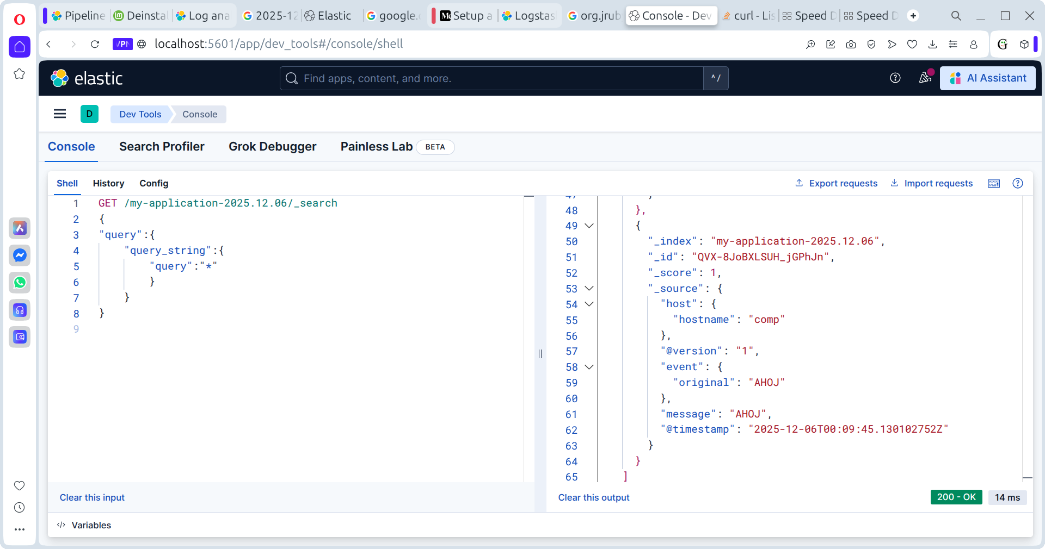
Grok parsing
\"%{GREEDYDATA:agent}\"

Elasticsearch
http://localhost:5601/app/dev_tools#/console/shell

Elasticsearch materials
https://github.com/LisaHJung/Beginners-Crash-Course-to-Elastic-Stack-Series-Table-of-Contents?tab=readme-ov-file

PARSING APACHE DATA
128.39.24.23 - - [25/Dec/2021:12:16:50 +0000] "GET /category/electronics HTTP/1.1" 200 61 "/category/finance" "Mozilla/5.0 (compatible; MSIE 9.0; Windows NT 6.1; Trident/5.0)"

%{IP:clientip} - - \[%{HTTPDATE:timestamp}\] \"%{WORD:verb} %{URIPATHPARAM:request} HTTP/%{NUMBER:httpversion}\" %{NUMBER:response} %{NUMBER:bytes} \"%{GREEDYDATA:referrer}\" \"%{GREEDYDATA:agent}\"

{ "request": "/category/electronics", "referrer": "/category/finance", "agent": "Mozilla/5.0 (compatible; MSIE 9.0; Windows NT 6.1; Trident/5.0)", "response": "200", "bytes": "61", "clientip": "128.39.24.23", "verb": "GET", "httpversion": "1.1", "timestamp": "25/Dec/2021:12:16:50 +0000" }
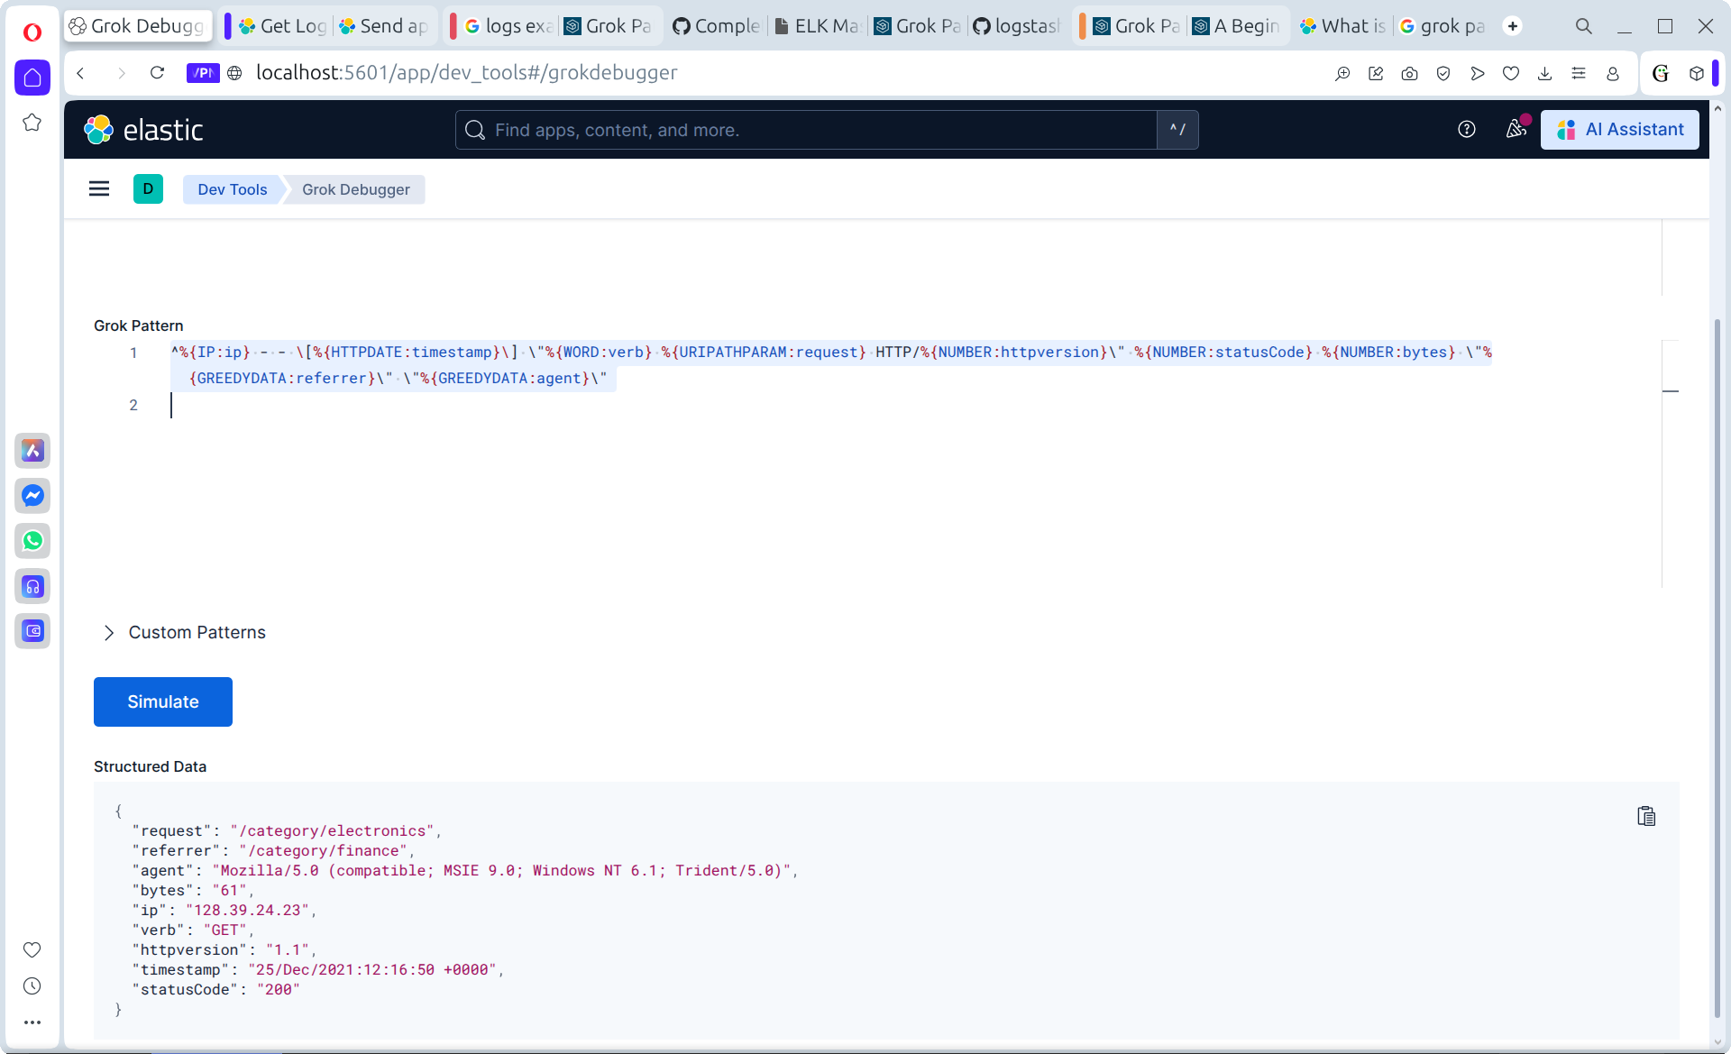
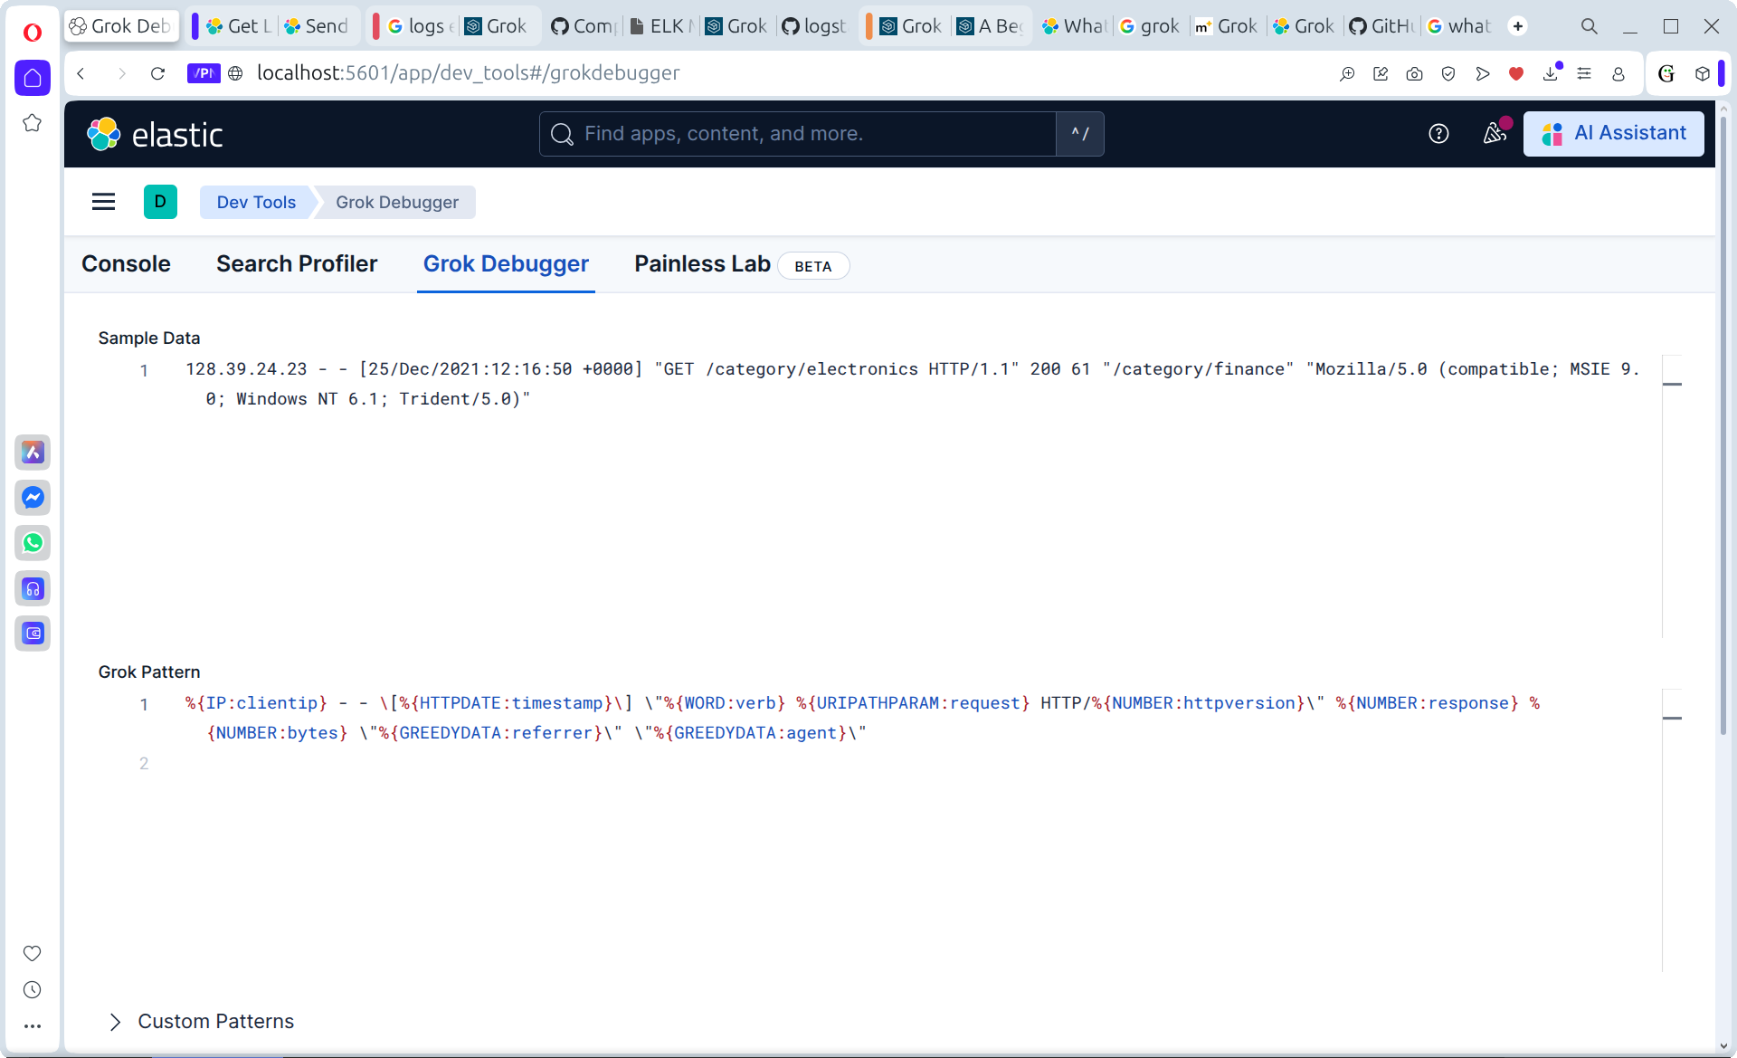

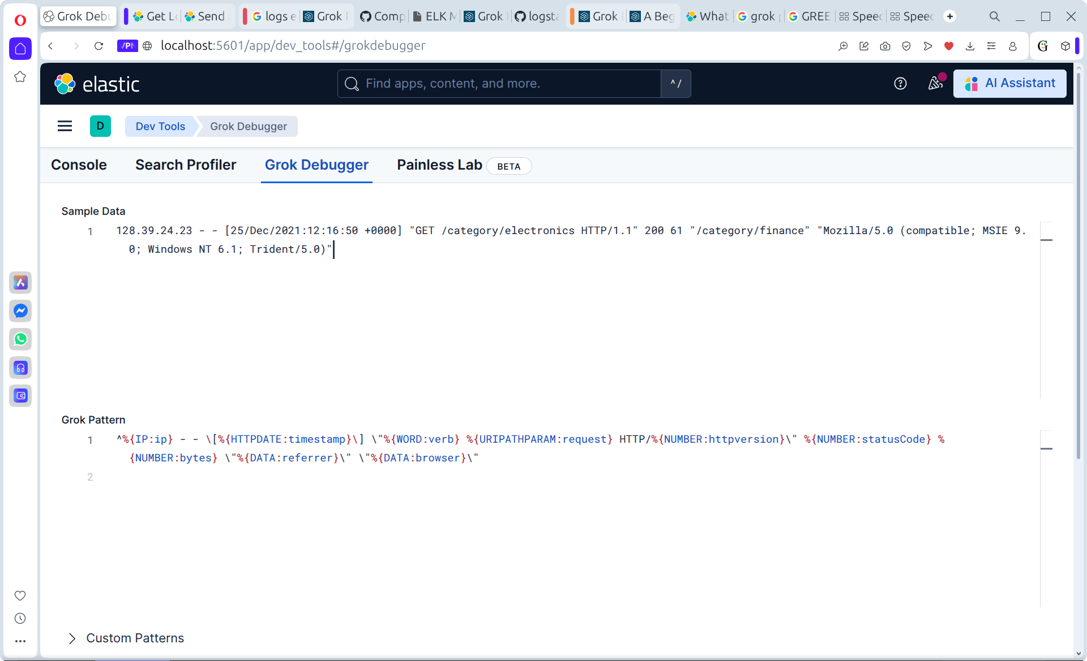
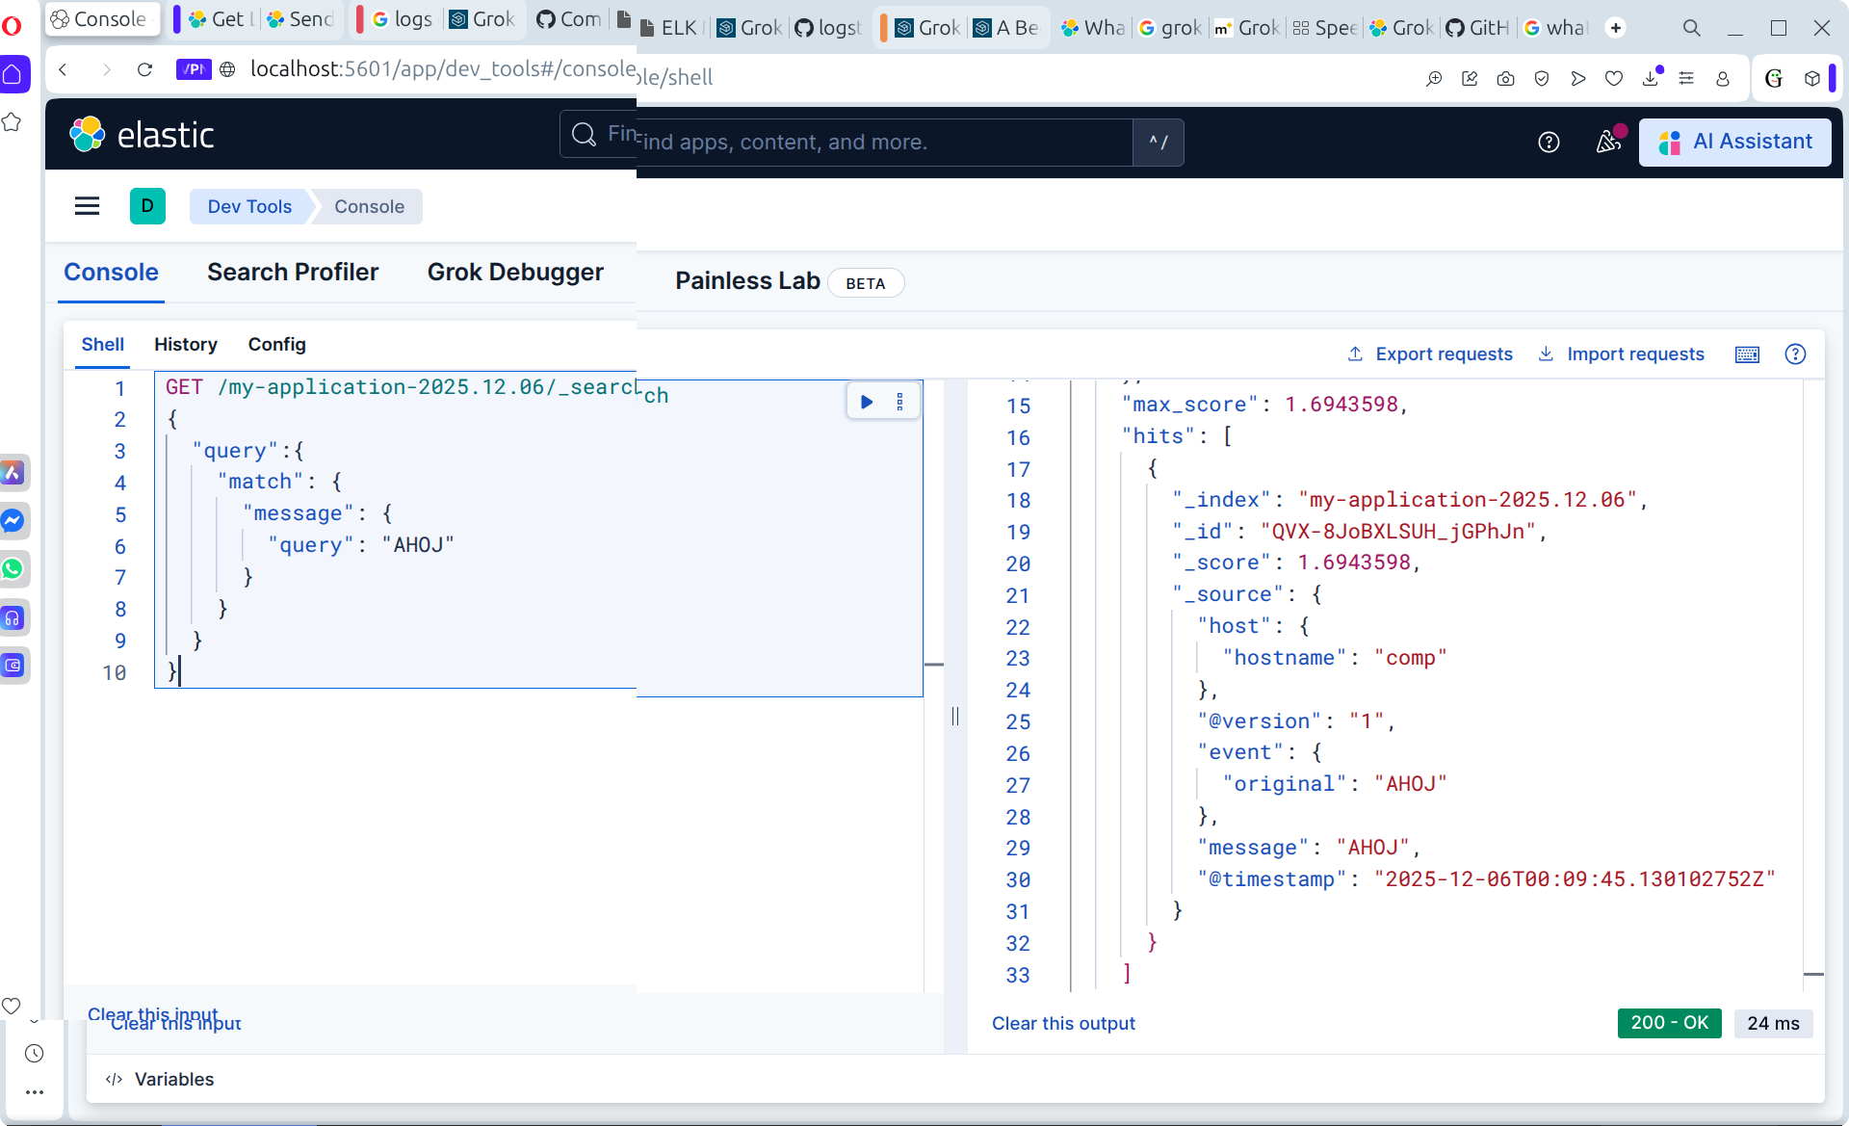
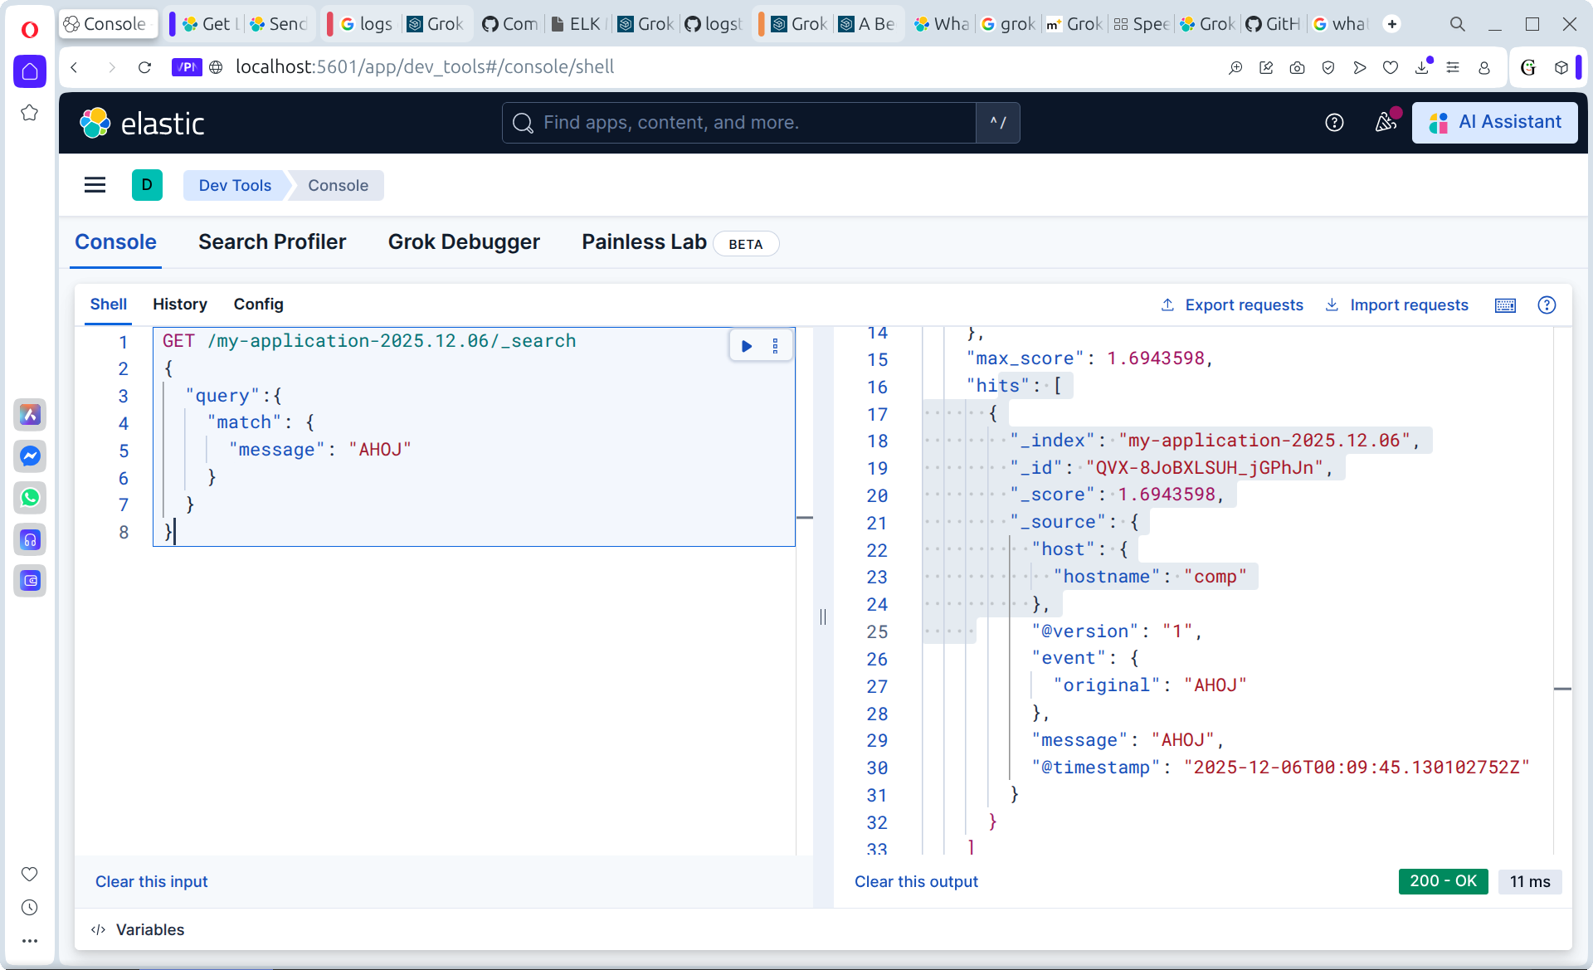
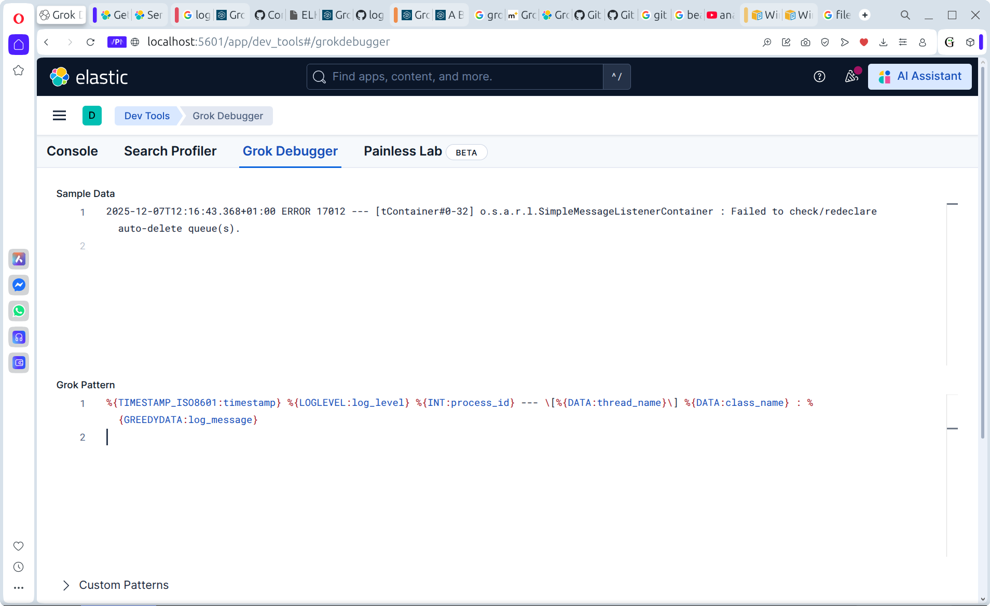
parsing backend log

example log message
2025-12-07T18:06:31.353+01:00 INFO 22697 --- [ main] com.angular.backend.BackendApplication : Starting BackendApplication v1.0.0 using Java 21.0.9 with PID 22697 (/home/ahanys/Desktop/zaloha2/datatables/myapp-jpa-server/target/myapp-jpa-server-1.0.0.jar started by ahanys in /home/ahanys/Desktop/zaloha2/datatables/myapp-jpa-server)

log parser
%{TIMESTAMP_ISO8601:timestamp}%{SPACE}%{LOGLEVEL:log_level} %{INT:process_id} --- \[%{DATA:thread_name}\] %{DATA:class_name}%{SPACE}:%{SPACE}%{GREEDYDATA:log_message}

%{TIMESTAMP_ISO8601:timestamp}%{SPACE}%{LOGLEVEL:log_level}%{SPACE}%{INT:pid}%{SPACE}---%{SPACE}\[%{%{SPACE}NOTSPACE:thread}\]%{SPACE}%{DATA:logger}%{SPACE}:%{SPACE}%{GREEDYDATA:message}
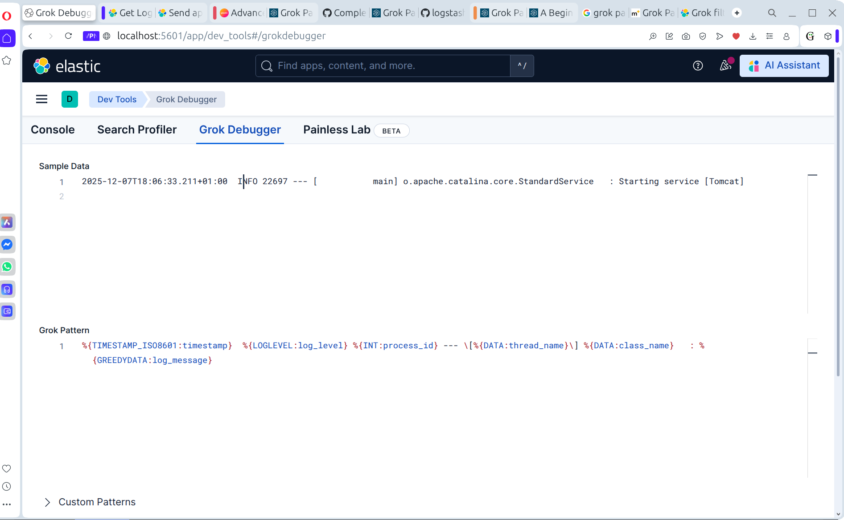

%{TIMESTAMP_ISO8601:timestamp}%{SPACE}%{LOGLEVEL:level}%{SPACE}%{INT:pid}%{SPACE}---%{SPACE}\[%{SPACE}%{NOTSPACE:thread}\]%{SPACE}%{DATA:className}%{SPACE}:%{SPACE}%{GREEDYDATA:msg}

2025-12-07T18:06:33.543+01:00 WARN 22697 --- [ main] ConfigServletWebServerApplicationContext : Exception encountered during context initialization - cancelling refresh attempt: org.springframework.beans.factory.BeanCreationException: Error creating bean with name 'entityManagerFactory' defined in class path resource [org/springframework/boot/autoconfigure/orm/jpa/HibernateJpaConfiguration.class]: Failed to initialize dependency 'flywayInitializer' of LoadTimeWeaverAware bean 'entityManagerFactory': Error creating bean with name 'flywayInitializer' defined in class path resource [org/springframework/boot/autoconfigure/flyway/FlywayAutoConfiguration$FlywayConfiguration.class]: Unable to obtain connection from database: Connection to localhost:5432 refused. Check that the hostname and port are correct and that the postmaster is accepting TCP/IP connections.

Restore postgresql db in docker container
docker cp /home/ahanys/Desktop/sample 5ac46fff7c95:/sample

LOGIN TO CONTAINER
postgres=# docker exec -it -u postgres 5ac46fff7c95 psql -U postgres -W password -d mywebshop

su postgres

CREATE DATABASE dvdrental;

connect to database dvdrental
\c dvdrental

import data to dvdrental database
pg_restore -c -U postgres -d dvdrental -v "/dvdrental.tar" -W

postgres=# psql -U postgres -W password -d dvdrental
postgres-# \c dvdrental
You are now connected to database "dvdrental" as user "postgres".

Where is stored information about installed software?
/var/lib/dpkg/status

SWAGGER URL:
http://localhost:9090/swagger-ui/index.html

Restore database dvdrental
root@comp:/# sudo -u postgres psql -d dvdrental -f /dvdrental.tar

